Download and Install Oracle Database 10g Express

For most applications, you only need to download and install the Oracle Database XE Server component, since it provides both an Oracle database and tools for managing this database. It also includes the Client component of Oracle Database XE, so that you can connect to the database from the same computer on which you installed the Server, and then administer the database and develop Visual Studio.NET applications.

- Download Oracle Database 10g Express Release 2

Go to: http://www.oracle.com/technology/software/products/database/xe/index.html and select the item Oracle Database 10g Express Edition for Microsoft Windows. Then check the radio button for the item Accept License Agreement to accept the OTN License Agreement. There are several versions of Oracle Database 10g Express available, such as the Western European and Universal. The first version is designed by using English and the second version provides multiple languages support. For your applications, the first version is good enough. So click on the first file named OracleXE.exe and click the Save button on the opened dialog to begin to download it into our Temp folder.
When the download is done, double click the downloaded file OracleXE.exe from our Temp folder and click the Run button to prepare to install this Server in our local machine. Exactly both an Oracle Server and an Oracle client will be installed in our computer when this installation is complete.
The next page displays a login dialog to allow you to sign in to this site before you can perform any download job. Click the sign up now item to begin this process.
In the opened sign in page, select Create your Oracle account now from the right-pane, and then enter you desired username and password followed by a clicking on the Confirm button to open the next page.
On the next page, enter your user information and click the Confirm button again to continue to the next page. You need to note that you should check the Unsubscribe checkbox if you do not want to receive any future Oracle electronic communications & subscriptions. Click the Submit button to continue. Click the Confirm button on the next page to make sure that you do not want to get more Oracle news.
When the File Download dialog appears, you can select either only download or download and install the database in one step by clicking either the Save or the Open button. In either case, the database will be downloaded into your machine and installed later. In our situation, the Open button is clicked and we want to download and install the database in one step. Make your selection and continue to the next step.
When the download is finished, the installation dialog is displayed, which is shown in Figure C-1.
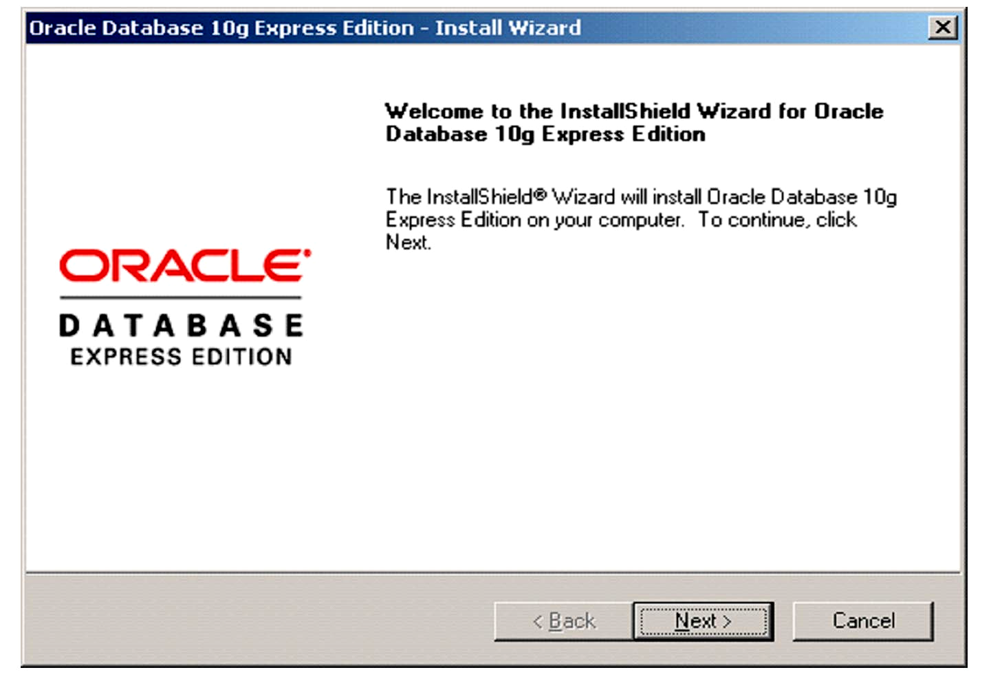

Figure C-1. The installation dialog

- Install the Oracle Database 10g Express Release 2

Click the Next button to begin to install the Oracle Database 10g Express Edition.
Select and click the Accept radio button followed by clicking the Next button to go to the next page. Click the Next button to open the next dialog.
In the next dialog, you need to enter your password. You must remember this password since you need to use it to access your database installed in the Oracle server from your client computer later. The username is SYSTEM by default. This means that you need to use the SYSTEM, which works as a User ID of an Administrator, as your username and the password you selected to open and access the database you created and installed in the Oracle server later.
Click the Next button after you entered your desired password, and then click the Install button to begin this installation, which is shown in Figure C-2.

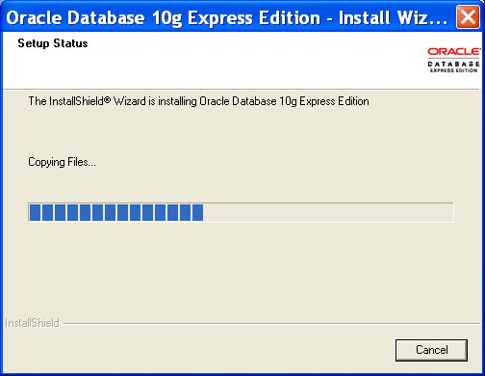

Figure C-2. The installation processing dialog

When this installation is complete, a finish dialog is displayed, which is shown in Figure C-3.
Click the Finish button to complete this installation.
The Database Login page is opened to allow you to enter your username and password to access the Oracle server to create, access and manipulate the data in the database you created in this server, which is shown in Figure C-4.

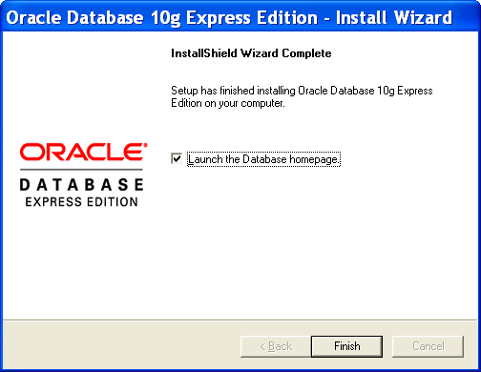

Figure C-3. The installation finishing dialog

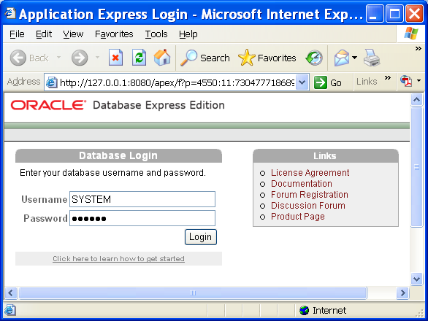

Figure C-4. The Database Login page

Enter the SYSTEM as your username and the password you selected when you installed the server, and then click the Login button to open the home page.
There are four icons on the opened home page, which is shown in Figure C-5.
The Administration icon is used to manage your whole database system, which including the storage utilization, memory space and database users. The SQL icon is used to help users to create and execute SQL statement in the Oracle database environment, which including the SQL Commands, SQL Scripts and Query Builder. The Utilities icon is used to convenient the user to perform data operations and actions, such as the data loading/unloading and object reports creation. For our applications, the most important icon is the Object Browser icon. By using this icon, you can create and browse database and all tables in the server.
You need to note that the Oracle Database 10g Express Edition Release 2 is a single-database instance database, which means that only a single instance of your database can be created and utilized with your applications. You cannot create multiple instances of your database at a time. But in most cases, single instance is good enough for our applications, and you can upgrade this Express Edition to the Oracle Standard 10g Database system if you like to handle multiple database instances later.

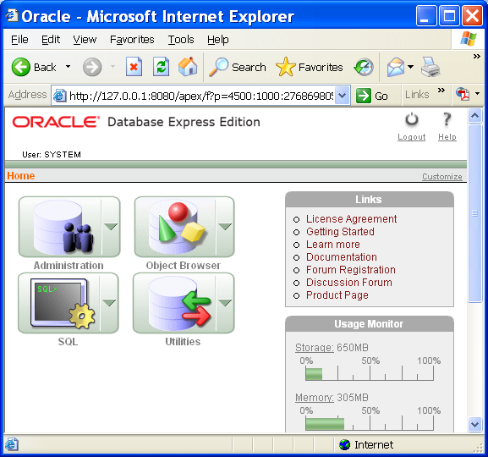

Figure C-5. The Database home page

At this point, you have successfully finished the download and installation of the Oracle Database 10g Express Edition Release 2, which include the Oracle Database 10g Express server and the client. A Database Started Guide icon has been automatically added to your desktop on your computer. You can open this icon to follow the guide to access your database if you like. To connect your client to the server and start creating, accessing and manipulating your database, you need to open the Database home page by clicking the Start|All Programs|Oracle Database 10g Express Edition|Go To Database Home Page. Then you can create and manipulate your database staring from the Object Browser icon.
To create the customer’s database in Oracle Database 10g XE, it is different to create a customer database in Microsoft Access or SQL Server database management system (MDBS). In Oracle Database 10g XE, you need to create a new user or user account if you want to create a new customer database. Each user or user account is related to a schema or a database, and the name of each user is equal to the name of the associated schema or database. Refer to Chapter 2 and Appendix D for detailed information in how to create a new user or user account as well as the associated customer database in Oracle Database 10g XE environment.

